**Week1**

**What is enterprise and examples?**

The definition of an enterprise is a project, a willingness to take on a new project, an undertaking or business venture. An example of an enterprise is a new start-up business. An example of enterprise is someone taking initiative to start a business

**Organizing the Enterprise - process**

**Five main steps involved in the process of organizing an enterprise.**

**1. Determining Activities**

**2. Grouping of Activities**

**3. Assigning Duties**

**4. Delegating Authority**

**5. Coordinating Activities.**

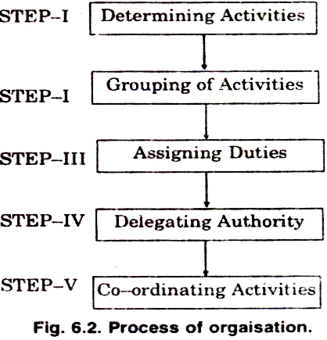

#### 1. Determining Activities

* The first step in organizing is to identify and enumerate (to specify one after another) the activities required to achieve the objectives of the enterprise.
* The activities will depend upon the nature and size of the enterprise.
* For instance, a manufacturing concern will have production, marketing and other.

#### 2. Grouping of Activities

* The various activities are then classified into appropriate departments and divisions on the basis of functions, products, territories, customers etc.
* Similar and related activities may be grouped together under one department or division.
* Grouping of activities helps to secure specialization. Each department may be further sub divided into sections and groups.

#### 3. Assigning Duties

* The individual groups of activities are then allotted to different individuals on the basis of their ability and aptitude.
* The responsibility of every individual should be defined clearly to avoid duplication of work and overlapping of effort.
* Each person is given a specific job best suited to him and he is made responsible for its execution.

#### 4. Delegating Authority:

* Every individual is given the authority necessary to perform the assigned task effectively.
* An individual cannot perform his job without the necessary authority or power.

#### 5. Coordinating Activities:

* The activities and efforts of different individuals are then synchronized. Such co-ordination is necessary to ensure effective performance of specialized functions.

## Understanding Business Activities

There are three main types of business activities: operating, investing, and financing.

* **Operating Activities**: Operating activities refer to all those business activities that are directly or indirectly related to the provision of goods and services. As such they have a direct impact on cash flow, and eventually on income.
* **Investing Activities**: Investing activities refers to all those activities that aimed to be capitalized for more than a year. This includes capital expenditure such as purchase of long term assets or real estate.
* **Financing Activities**: Financing activities refer to all those activities that fund the business but are not directly related to the revenues from goods and services. Common financing activities include bonds, loans, and share issues

### What is a business process?

A business process is an activity or set of activities that accomplish a specific organizational goal. Example

* Manufacturing
* Quality Assurance
* Packaging
* Shipping
* Purchasing

## What is Business Process Automation?

* Business process automation ([BPA](https://checkify.com/blog/business-process-automation-software/)) is a subset of a [business process managemen](https://checkify.com/blog/business-process-management/)t (BPM).
* It is the use of computer software or hardware to replace, control or automate repetitive business tasks.
* The main aim of automation is to reduce or eliminate processes that either don't add value or have a high potential for human error.
* In other words, anything that can be done by a machine should be.
* This helps you run more efficiently but can also save you money and ensure that operations are done correctly.

## Why automate business processes?

* Automating business processes is good for your employees.
* It frees up their time so they can focus on higher-level tasks instead of spending most of their day answering similar questions over and over. Plus, it offers a lot more efficiency in the long run.
* Automation helps you get your work done faster and more efficiently, thereby saving money and time, which you can then invest in other things.

### ****Business division and their activities in a software company****

According to their duties, people create their individual departments in a company such as

1. **IT Department**

* IT Department is a core of every software company.
* It has created by the group of software professionals who are technical part of the project.
* Duties within this department are divided among Developers, Project Managers and QA specialists.

#### UX/UI Department

#### Here the graphic part of the project is created.

#### UX design stands for user experience design, while UI design stands for user interface design.

#### Create interfaces that are both effective and easy to use.

#### As a result they design the whole application and its individual components.

#### While creating the product, they work closely with the IT Department.

#### Business Development Department

* Business Manager who is the first to have contact with the potential customer.
* Exhaustive meetings with all team members and regular updates to client will follow and once all features are defined the development team will begin building the product. Collaboration and communication between all teams.

#### Marketing Department

* Responsible for creating the company's image on the market.
* Starting from the design of the website, through advertising, presence on industry portals and press releases

#### HR Department

#### Their main objective is to create the best possible team of dedicated and reliable employees

#### They are also aimed at staff development programs, improvement of staff efficiency and career pathing.

#### They play an important role in creating and implementing health and safety regulations within the company.

#### Accounting and finances Department

* This department takes care of every financial aspect among the company.
* Also their aim is to control document flow and all settlements with partners.

#### Board of Directors

* They are responsible for coordinating the design, development, and implementation of an organization's applications.
* Director of software development, your responsibilities are to oversee the organization and daily operations of a software development.

**Workflow**

* A Workflow is defined as a sequence of tasks that processes data through a specific path from initiation to completion. They can be used to structure any kind of business function regardless of industry. Essentially, anytime data is passed between humans and/or systems, a workflow is created.

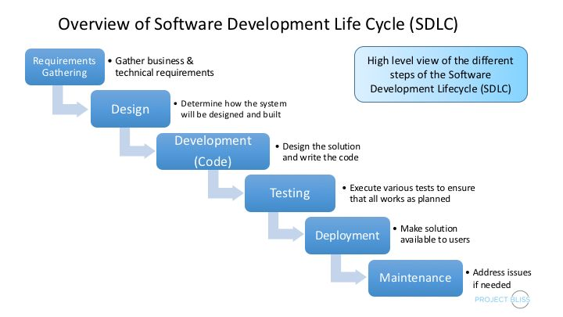

**Design Thinking**

Design thinking enables software development companies to test the feasibility of the future product and its functionality at the initial stage. It allows them to keep end user needs in mind, clearly specify all requirements and translate all this into product features

**Design thinking for software development**

Design Thinking is a 5-step process to come up with meaningful ideas that solve real problems for a particular group of people.

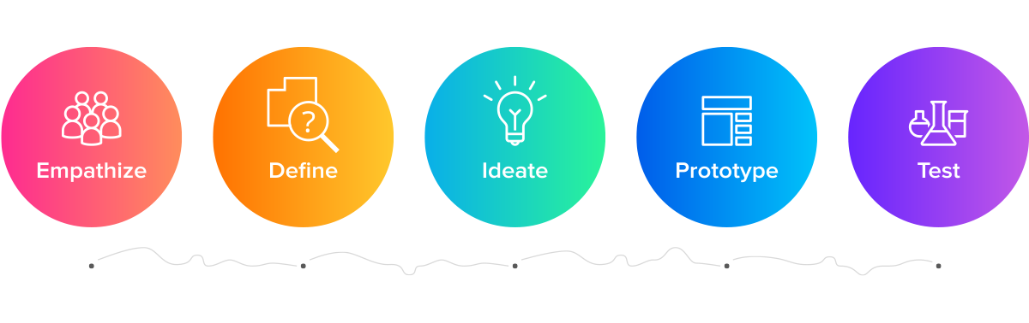

**The five steps in design thinking are:**

* Empathize: Understand the user’s needs and perspective
* Define: Define the problem that needs to be solved
* Ideate: Generate new and innovative ideas.
* Prototype: Create a prototype of the product.
* Test: Test the product with actual users to get feedback

**Full-Stack Development**

* Full-stack development refers to building end-to-end software solutions including front-end and back-end development.
* Front-end refers to the front part of the application or UI which is seen by the end-user and used for end-user interaction.
* The back-end part is related to server-side development, database, and API development.

## What is a full-stack web developer?

* Full stack web developers have the ability to design complete web applications and websites. They work on the frontend, backend, database and debugging of web applications or websites.
* 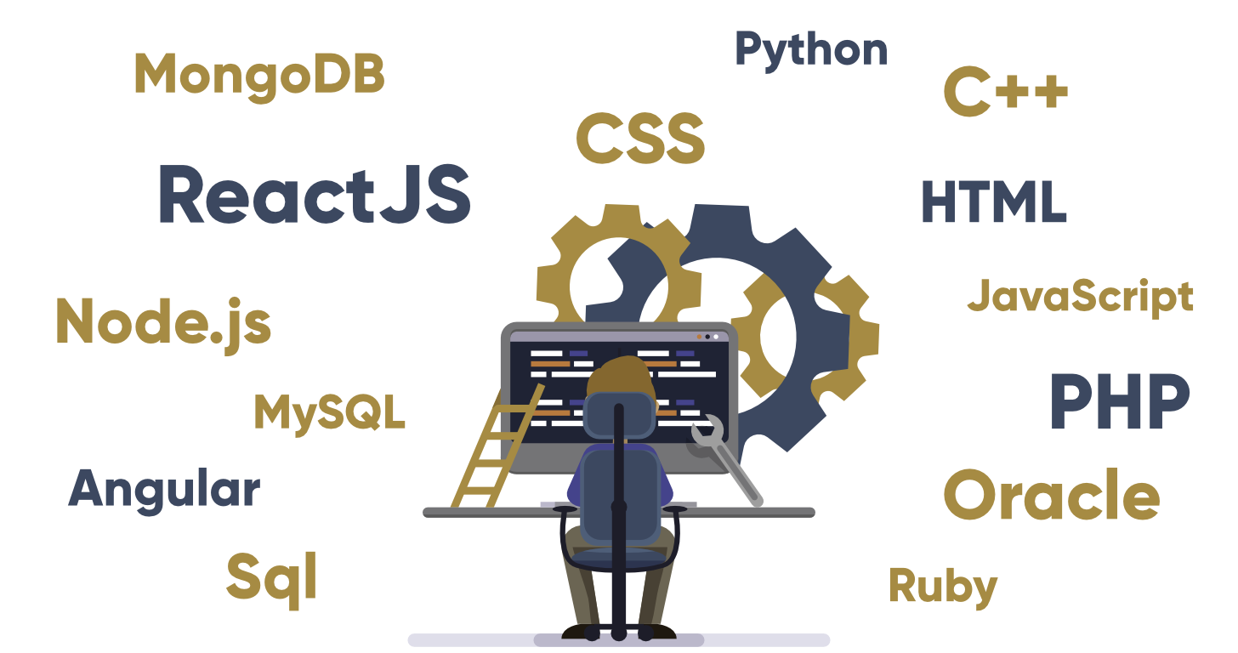They are proficient (Skilled or expert) in both frontend and backend languages and frameworks, as well as in server, network and hosting environments.

### What is project planning?

Project planning is a discipline addressing how to complete a project in a certain timeframe, usually with defined stages and designated resources. One view of project planning divides the activity into these steps:

* setting measurable objectives
* identifying deliverables
* scheduling
* planning tasks

**How to create project plan**

The **software plan** prevents hurdles that tend to crop up during the project’s execution. It also ensures optimal utilization of every allotted resource and time.

1. **Define your scope:**

* A project's scope describes the goals needed to complete the project successfully.
* Defining your scope, consider project aspects like outcomes, tasks, budget, time frame and deliverables.
* You can define these by writing them in sentences or creating a bulleted list within your software project plan document.

1. **Define and coordinate your requirements:**

* Identify appropriate resources that will help you to meet the objectives.
* Define the other aspects of the project such as equipment, [budget for software development](https://www.laneways.agency/how-much-does-custom-software-cost/), team, skills, and timeline.

1. **Understand your constraints:**

* Project may encounter unexpected events that may adversely affect it. Such as increase in costs, delayed results, technical and business etc.
* Such hurdles include support from the management, appropriate schedule, appropriate budget, and [skilled software developers](https://www.laneways.agency/how-to-become-a-software-developer/).

1. **Map your business processes:**

* Business process mapping is a powerful technique to visually depict process steps and show how a process should function from start to finish.

1. **Estimate your budget:**

* The estimates will help you get an idea of the money and time you need.

1. **Draw up your staged deliverables:**

* Next task is to draw software development milestones to give room for testing and feedbacks at each phase.
* Milestones ensure the [software development team](https://www.laneways.agency/create-an-effective-software-development-team/) focuses on specific functionality aspects.
* When planning tasks and features to be done at the various phases, concentrate more on achieving original targets.

1. **Create a team:**

* Project management requires one or several teams of professionals with the right experience and skills.
* If your company lacks these individuals, you may hire from outside or outsource the recruitment process to a company that will put together the teams for you.

1. **Discuss quality and progress:**

* Your planning is not yet over until you include the progress checks and quality testing.
* Testing your stages ensures you’re meeting your milestone goals.

**What is a product backlog?**

A product backlog is a prioritized list of work for the development team that is derived from the roadmap and its requirements. The most important items are shown at the top of the product backlog so the team knows what to deliver first.

## Steps to create a product backlog

A product backlog is more than a simple to-do list—it’s where you break down complex tasks into a series of steps and [delegate](https://asana.com/resources/how-to-delegate) them to team members.

### 1. Build a product roadmap

The product roadmap is the foundation for the product backlog. Your team should create a roadmap first, which will then serve as the [action plan](https://asana.com/resources/action-plan) for how your product will change as it develops. The roadmap is the vision for long-term product development, but it can also evolve.

### 2. List product backlog items

These items should include both high-priority items and more abstract ideas. During this phase of product backlog creation, you’ll also need to communicate with [stakeholders](https://asana.com/resources/project-stakeholder) and listen to their ideas for product improvements.

### 3. Prioritize your backlog

After your team lists all the product backlog items, sort and [prioritize your most important tasks](https://asana.com/resources/how-prioritize-tasks-work). You can identify top-priority items by putting the customer front of mind and considering what items provide the most value to them.

### 4. Update regularly

As your team works through the product backlog, remember that it’s a living document. You can continuously add items to the backlog and prioritize or refine them as you work.

**Components of Full stack development**

* Front End
* BackEnd

**Front end:** It is the visible part of website or web application which is responsible for user experience. The user directly interacts with the front end portion of the web application or website.

**Front end Languages:**

* [HTML](https://www.geeksforgeeks.org/html-tutorials/)
* CSS
* JavaSccript
* Libraries
* CSS Processors
* Build Tools
* Frameworks

**Front End Frameworks and Libraries:**

* [AngularJS](https://www.geeksforgeeks.org/category/web-technologies/angular-js/):
* [React.js](https://www.geeksforgeeks.org/react-js-introduction-working/):
* [Bootstrap](https://www.geeksforgeeks.org/bootstrap-tutorials/):
* [jQuery](https://www.geeksforgeeks.org/jquery-tutorials/):

**Back end:** It refers to the server-side development of web application or website with a primary focus on how the website works. It is responsible for managing the database through queries and APIs by client-side commands.

* [PHP:](https://www.geeksforgeeks.org/php/)
* [C++](https://www.geeksforgeeks.org/c-plus-plus/)
* [Java:](https://www.geeksforgeeks.org/java/)
* [Python:](https://www.geeksforgeeks.org/python-programming-language/)
* [JavaScript:](https://www.geeksforgeeks.org/javascript-tutorial/)
* [Node.js](https://www.geeksforgeeks.org/introduction-to-nodejs/):

**Database**

* + Oracle: Oracle database is the collection of data which is treated as a unit. The purpose of this database is to store and retrieve information related to the query. It is a database server and used to manage information.
  + [MongoDB](https://www.geeksforgeeks.org/mongodb-an-introduction/): MongoDB, the most popular NoSQL database, is an open source document-oriented database. The term ‘NoSQL’ means ‘non-relational’. It means that MongoDB isn’t based on the table-like relational database structure but provides an altogether different mechanism for storage and retrieval of data.
  + [Sql](https://www.geeksforgeeks.org/sql-tutorial/): Structured Query Language is a standard Database language which is used to create, maintain and retrieve the relational database.

**Full stack development** Tools

* Backbone
* Code pen
* Visual Studio Code
* Type Script
* Web Strom
* GitHub
* Electron

**Top 10 Front-End and Back-end Frameworks for Full-Stack Developers**

### 1. React JS [Best JavaScript GUI library]

### 2. Spring Boot [Best Java Backend Framework]

### 3. Angular [Best JavaScript GUI Framework]

4. Node JS + Express.js [Best JavaScript Backend Framework]

### 5. Django [Best Python Full Stack Framework]

### 6. Flask [Best Python Backend Framework]

7. Bootstrap [Best CSS Framework for Web Development]

### 8. jQuery [Best JavaScirpt library]

9. Ruby on Rails [Best Ruby Framework for Web development]

10. GraphQL [Best JavaScript library for APIs]

**Digital Transformation:**

Digital transformation is the process of using digital technologies to create new or modify existing business processes, culture, and customer experiences to meet changing business and market requirements.

**Examples of Digital Transformation:**

* The digital transformation of Netflix.
* NIKE's Digital Transformation through SNKRS App.
* AUDI's Digital Showroom.
* Adobe's Digital Transformation.

**The 4 Main Areas of The Digital Transformation Process**

* Process Transformation. Business process transformation is a strategic initiative aimed at improving the efficiency and effectiveness of a company's operations.
* Business Model Transformation.
* Domain Transformation.
* Cultural/Organizational Digital Transformation.

**Digital Transformation convergence of IT and OT:**

IT systems are used for data-centric computing, OT systems monitor events, processes and devices, and make adjustments in enterprise and industrial operations.

IT/OT convergence is the integration of information technology (IT) systems with operational technology (OT) systems.

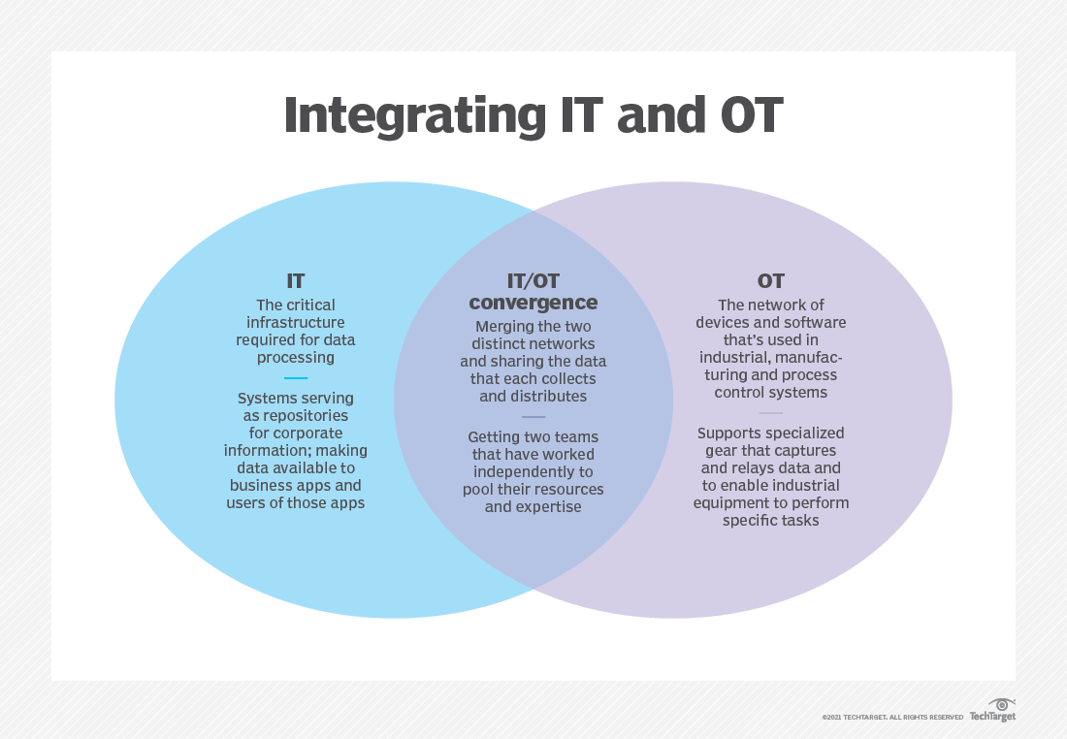

**How technology has impacted digital transformation?**

* Digital transformation using various technology to change the business process and help them to become more productive.
* It enables businesses to modernize legacy processes, accelerate efficient workflows, strengthen security, and increase profitability.

**Digital Transformation Success Stories:**

### ****Nike****

* Nike, the global sportswear leader, Nike’s entire approach to branding, sales, and technology has changed using digital transformation.
* They now focus on becoming a robust direct-to-consumer brand, reducing their retail partnerships, and increasing their work to create online sales.
* Programs like Nike Training Club collect detailed consumer data and use advanced analytics to make sense of the patterns.
* Smaller physical stores now do a lot of work to promote the Nike brand.
* They use multiple online sales channels, with particular expansions into mobile apps and technology.
* Like IKEA, Nike has dominated their market section for a long time.